GMI German-Malaysian Institute

DIPLOMA PROGRAMME
Practical Test
Academic Period: JANUARY 2026

Program | : | DIPLOMA IN CYBER SECURITY
Course | : | INTRUSION DETECTION AND PREVENTION SYSTEMS
Code | : | CIT 0592
Duration | : | 2 Hours
Total Marks | : | 50

GENERAL INSTRUCTIONS:

- Write down clearly (with capital letters) your name, trade, group and the date of examination at the bottom of this page.
- Do not open this question booklet until you are told to do so by the invigilator.
- Read the specific instructions and questions carefully before answering.

This paper consists of 7 printed pages, including this page.

Student’s Name | : | ABDUL HARIZ B. MOHD SARNUDIN
Student’s I/D No. | : | CBS24070208
TTO’s Name | : | MR MOHD AIMAN HANIF APANDI
Semester/Trade/Group | : | SEM 4 / DCBS / CBS 1
Date | : | 11/5/2026

No | Assessment Criteria | CLO | PO | Level of Diff | Full Marks | Score | Marks | Comment
1. | Installation of Snort and VM/OS | 2 | 2 | P3 | 15
2. | i. Configure IP address  ii. Configure Snort  iii. Troubleshooting and Testing | 2 | 3 | P3 | 17
3. | i. Create icmp rule  ii. Create alert rule  iii. Troubleshooting and Testing | 2 | 3 | P3 | 8
4. | Knowledge | 3 | 4 | C2 | 10
Total |  |  |  |  | 50
Total Marks |  |  |  |  | /50 /30
Signature |  |  |  |  | 

Learning Objectives

- To install Operating System using Linux
- To install, configure and test Snort
- To configure and test Snort Rule

NO. | CRITERIA | APPROACHES EXPECTATIONS M[1] | MEETS EXPECTATIONS M[2] |  | EXCELLENT M[3] | MARKS
1 | Installation of Snort and VM/OS | Unable to install Linux server and Snort  0-5 marks | Able to partially install Linux server and Snort  6-10 marks | Able to install Linux server and Snort with full functionality  11-15 marks
2 | i. Configure IP address  ii. Configure Snort  iii. Troubleshooting and Testing | Unable to install, configure and test IP address and Snort  0-6 marks | Able to partially install, configure, and test IP address and Snort  7-12 marks | Able to install, configure and test IP address and Snort with full functionality  13-17 marks
3 | i. Create icmp rule  ii. Create alert rule  iii. Troubleshooting and Testing | Unable to configure and test icmp and alert rule  0-3 marks | Able to partially install, configure, and test icmp and alert rule  4-6 marks | Able to install, configure and test icmp and alert rule with full functionality  7-8 marks
4 | Knowledge | Not able to answer questions, not prepared and no confidence at all  0-3 marks | Able to answer questions but with little preparation and confidence  4-7 marks | Able to all answer questions very well and confidently. Very well prepared  8-10 marks
 | TOTAL

Create new OS installation and new SNORT installation. (40+10)
- You need to install and setup snort successfully. You are about to protect your host and not using all the rules that currently available by default.
Submission:
- Attach screen capture the location of your new installed VM folder with ‘Date Created‘ option (right click on the tab above the folder location and tick date created) here. Make sure the name of your VM file and date created should visible.
Example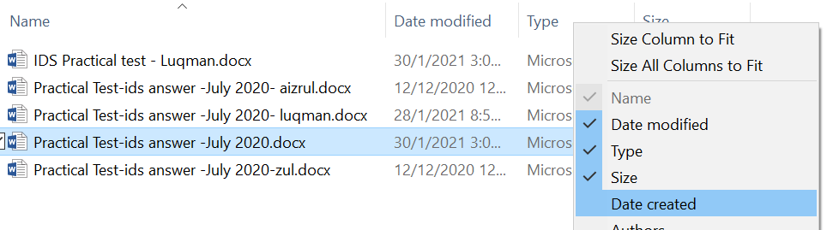

Your VM Location with Date Created (paste screen capture here)
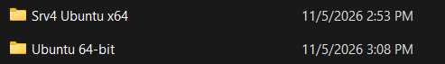

- Attach your snort.conf upon submission to get marks below.

Task | Marks(32)
- Install vmware | 5
- Install Snort | 10
- Assign ip address for host in snort conf | 2
- Disable all rules in snort conf | 5
- Able to run snort successfully | 10

1. Install VMware
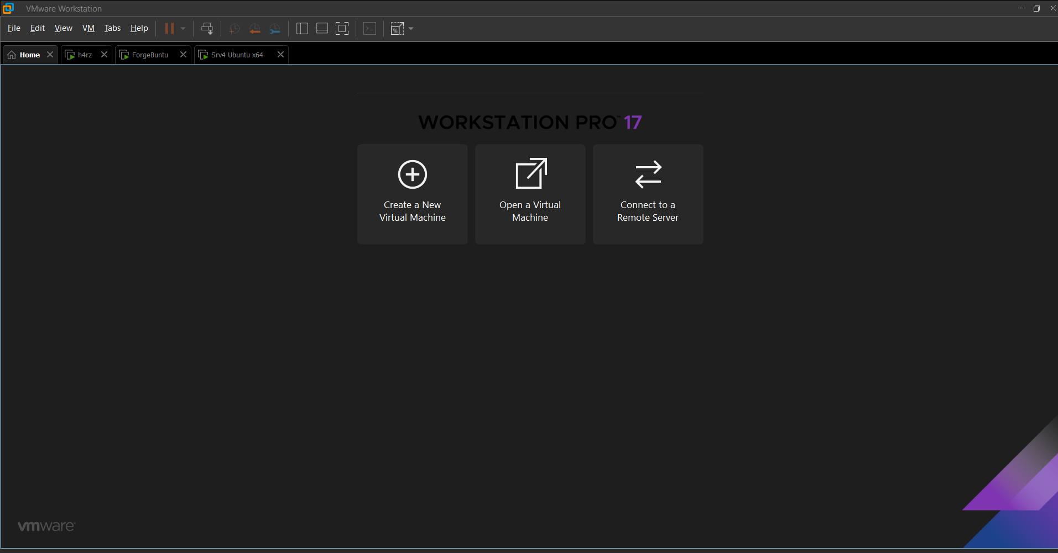
2. Install Snort
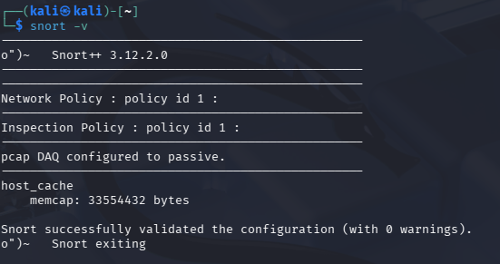
3. Assign IP Address for Host in Snort Conf.
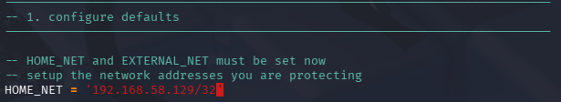

4. Disable all rules in snort conf
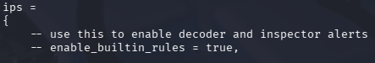
5.
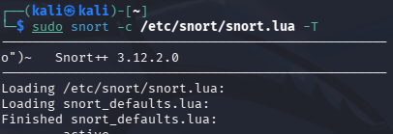
- Create your own rules to detect activities and produce alert such list below (10 marks):

Activity | Alert | Marks
- Ping traffic from vm/physical machine to the snort machine | Somebody is accessing my snort machine
Details:
Task Activity A | Marks (8)
- Create icmp rule file as test.rule | 2
- Create rule  -Rules definition in test.rule  -alert warning in test.rule  Establish test.rule in snort conf | 2  2
- Test the rule | 2
Proof of Concept :
Attacker Machine
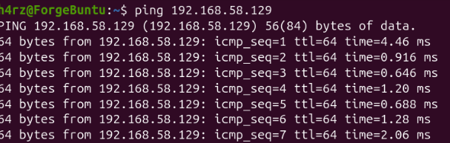
Snort Machine
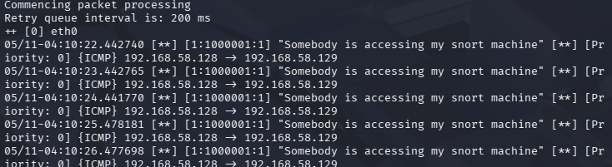

Submission:

- Attach test.rule

- Screen shot the output of command of snort testing below.

- /usr/local/bin/snort -T -i eth0 -u snort -g snort -c /etc/snort/snort.conf
(etch0 can be replaced with your own interface)
- date (to know the exact time of your testing)
- Name: yourname (its ok if there is error)
Output from activity above (paste screen capture here)
i)
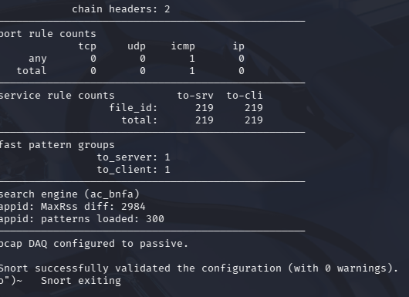
ii)
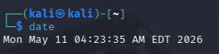
iii)
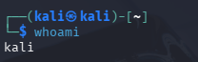 (hariz)

- Attach your log file generated from command:
snort -dve -i eth0 -c/etc/snort/snort.conf -l /var/log/snort/
(etch0 can be replaced with your own interface)

OR
snort -c /etc/snort/snort.conf -K ascii -l /var/log/snort

Location file with date created of output from activity above
(paste screen capture here)
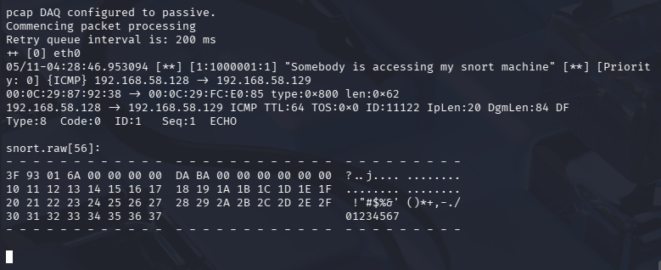

- Answer these questions (10 Marks):

- Determine file you need to configure for activity question (2) above? (2 marks)

/etc/snort/snort.lua

- Where to view alerts and its history? (2 marks)

Alerts can be viewed in two places:

- The Terminal (Console): If running Snort with the -A alert_fast or -A cmg flag without a redirect, alerts appear in real-time on your screen.

- Log Files: For a permanent history, alerts are stored in text files (typically named alert_fast.txt or alert_full.txt) generated by Snort's alert modules.

- Determine the path for answer question 3(2) above. (2marks)

/var/log/snort/

- Write an alerts definition provided in your log (according to instruction 2(e) above) and explain (what kind of information you get from these alerts). Form a table (2marks for each alert definition and explanation). (4 marks)

Sample Alert String:
05/11/26-16:45:10.123456 [] [1:1000001:1] "Somebody is accessing my snort machine" [] [Priority: 0] {ICMP} 192.168.58.128 -> 192.168.58.129

Explanation :

{ICMP} -> Protocol: Identifies the type of network traffic (in this case, a Ping or Internet Control Message Protocol).

192.168.58.128 -> .129 -> Source & Destination: Shows the IP address of the "attacker" (the .128 machine) and the "target" (your Snort machine).

Checklist of submission:
- Question paper with answers and screenshots.
Screenshots:
  - VM Location with Date Created
  - Snort testing output
  - Log file Location with Date Created
- test.rule attachment
- snort.conf attachment
- log file attachment

THE END

